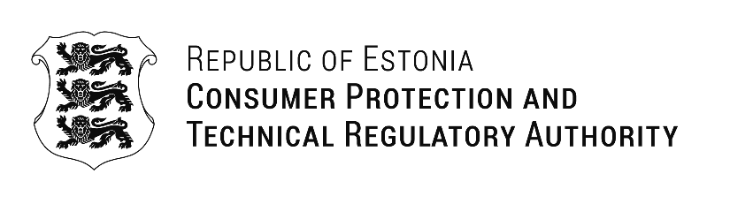

RUTH PASERMAN  The European Commission’s Directorate-General for Employment, Social Affairs and Inclusion (DG EMPL) | Our Ref: 13.02.2025 No 1-9/2025/0169
Request for Funding Support for an In-Person Market Surveillance Meeting (EAA)
Dear DG-EMPL,

Consumer Protection and Technical Regulatory Authority (CPTRA) of Estonia, among other responsibilities, oversees the market surveillance of the accessibility of products under Directive 2019/882 (the European Accessibility Act, EAA).
According to Article 28 of the EAA, the European Commission is required to establish a working group comprising representatives from market surveillance authorities. However, this has not yet been implemented. Recognizing the urgent need for collaboration and knowledge exchange, CPTRA took the initiative to form an informal working group exclusively for market surveillance authorities (MSAs) focused on product accessibility. Since its establishment in October 2024, the group has grown to include more than 50 members from 19 countries.
The EAA requirements will come into force on June 28, 2025, yet many Member States still face numerous unresolved questions regarding their implementation and enforcement. Ensuring a consistent and effective approach across the EU is crucial, particularly given the complexity of the directive and the diverse national frameworks.
To date, we have successfully conducted three online meetings, which have been productive and have provided valuable insights. However, while virtual meetings facilitate discussions, they do not allow for the same level of engagement, depth of exchange, or networking opportunities as face-to-face interactions. Given the complexity and novelty of accessibility requirements under the EAA, it is crucial for MSAs to build a strong network, share enforcement strategies, and ensure a harmonized approach across the EU.
We strongly believe that an in-person meeting would significantly enhance the effectiveness of this collaboration by:
- encouraging more dynamic discussions that are often limited in virtual settings.
- facilitating deeper exchanges of best practices and case studies, which are critical for a consistent interpretation and enforcement of the EAA.
- strengthening cooperation between MSAs to ensure a harmonized and efficient approach to market surveillance.

To organize this in-person meeting, we would like to explore the possibility of securing one-time financial support from DG-EMPL. The requested funding would be used to cover the costs of:
- one night's accommodation for attendees (one representative per Member State).
- transport costs to and from the meeting location.
- meeting-related expenses, including a working luncheon.

The requested funding would be used to cover the costs of (approx.):
Cost Item | Amount (€)
Accommodation (25 participants × 80 €/night) | 2 000 €
Transport (Flights) (25 participants × 500 €) | 12 500 €
Lunch (25 participants × 30 €) | 750 €
Total | 15 250 €

We propose that attendees arrive the evening before the meeting and depart on the same evening following an eight-hour structured discussion session.
We have deliberately postponed presenting this idea to the informal working group until we confirm the feasibility of obtaining funding. If such funding is available, we will coordinate with the group to determine the most suitable arrangements for the majority.
Given the importance of ensuring the effective implementation and enforcement of the EAA across all Member States, we sincerely hope that DG-EMPL will recognize the value of this initiative and consider supporting our request.
If this request does not fall within your direct responsibilities, we kindly ask you to direct us to the appropriate contact person. We appreciate your time and consideration and look forward to your response.

With best regards,
Jana Baljutis-Kütt
Head of Product Safety Division

Elina Jõgi
Elina.Jogi@ttja.ee

